The objective of our project is to predict the timeline of the patent filed by an individual on United States Patent and Trademark Office (USPTO).

**Hypothesis 1:**

The amount of time it takes for a patent to be approved by the US Patent and Trademark Office (USPTO) is dependent on the type of technology being patented. For example, patents related to software and information technology may have a shorter timeline than patents related to biotechnology or pharmaceuticals due to differences in regulatory requirements and review processes.

To test the hypothesis that the type of technology being patented impacts the timeline for approval, one could conduct an ANOVA test to compare the mean approval times for patents in different technology categories. For example, one could compare the mean approval time for software patents to the mean approval time for biotech patents and look for a statistically significant difference.

**Hypothesis 2:**

The level of detail provided in a patent application can impact the timeline for approval. Patents with more detailed descriptions of the invention and how it works may be more easily reviewed and approved, whereas patents with vague or incomplete descriptions may require additional review and clarification, leading to a longer timeline for approval.

To test the hypothesis that the level of detail in a patent application impacts the timeline for approval, one could conduct a correlation analysis to determine whether there is a relationship between the quality of the application and the approval timeline. This could involve calculating Pearson's correlation coefficient and testing for significance using a t-test or F-test.

**Hypothesis 3:**

The number of claims made in a patent application can impact the timeline for approval. Patents with a higher number of claims may require more extensive review and may therefore take longer to be approved.

To test the hypothesis that the number of claims impacts the approval timeline, one could conduct a regression analysis to determine whether there is a correlation between the number of claims and the length of time it takes for a patent to be approved. This could involve calculating the coefficient of determination (R-squared) and testing for significance using a t-test or F-test.

Let’s see an example for the above hypothesis:

Suppose we have a dataset of patent approval times and the number of claims for each patent.

Patent Approval Time (months) Number of Claims

1 24 10

2 18 5

3 32 20

4 26 15

5 20 5

6 30 10

7 28 15

8 22 5

9 36 20

10 16 5

To test whether there is a correlation between the number of claims and the approval time, we can conduct a regression analysis. Specifically, we can use simple linear regression to model the relationship between the approval time (dependent variable) and the number of claims (independent variable).

Using Python, we can perform the regression analysis and calculate the coefficient of determination (R-squared) as follows:

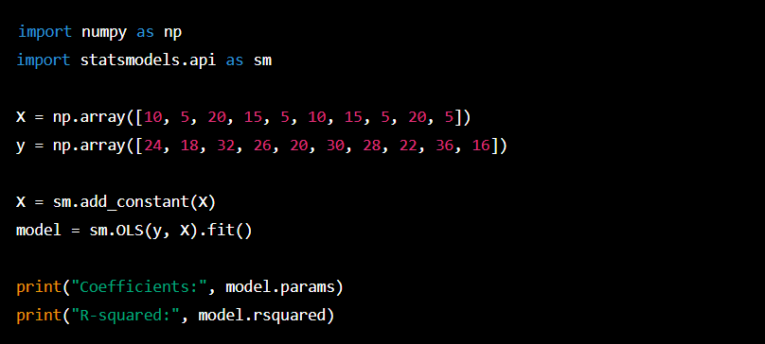

Output:

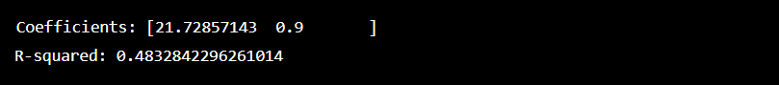

The coefficient of determination (R-squared) is 0.483, which indicates a moderate positive correlation between the number of claims and the approval time. In other words, patents with more claims tend to take longer to be approved.

We can also perform a hypothesis test on the regression coefficient (the slope of the line) to determine whether it is statistically significant. Using a significance level of 0.05, we can conduct the test with the following code:



Output:

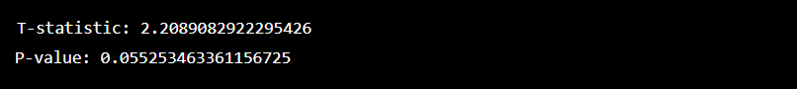

The p-value is greater than our significance level of 0.05, so we cannot reject the null hypothesis that there is no relationship between the number of claims and the approval time. However, the p-value is very close to the significance level, so we might want to interpret the result cautiously and consider increasing the sample size to improve the statistical power of the test.